Test Case: tc002_SPX_Dev5_Crear_Requisicion_Spot_Tipo_Cobro_Project
Step 1 - Enter username and password and click to button Enter: Credentials Entered
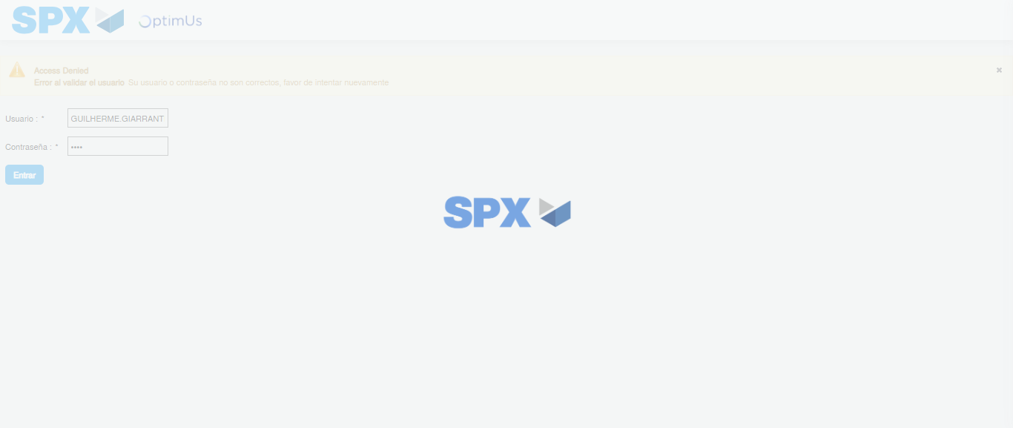Image file-name: QC_Testing-tc002_SPX_Dev5_Crear_Requisicion_Spot_Tipo_Cobro_Project-1784309423355

Step 2 - Select to UEN and Access to Spot Buy Requisitions : UEN Correctly selected and Correct access
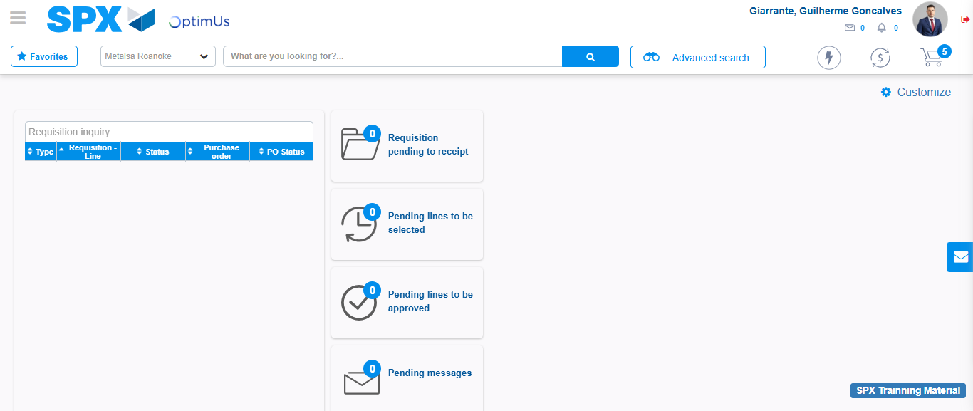Image file-name: QC_Testing-tc002_SPX_Dev5_Crear_Requisicion_Spot_Tipo_Cobro_Project-1784309451656

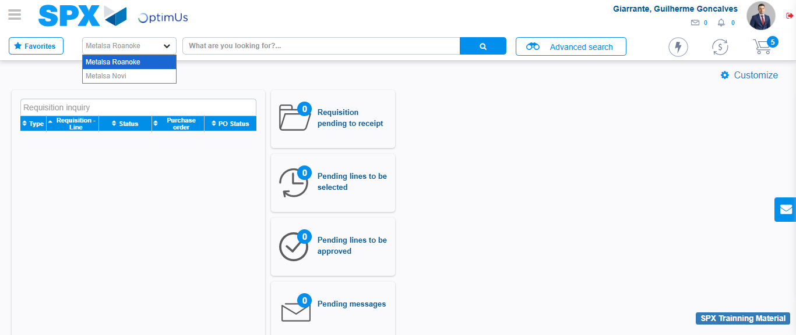Image file-name: QC_Testing-tc002_SPX_Dev5_Crear_Requisicion_Spot_Tipo_Cobro_Project-1784309454224

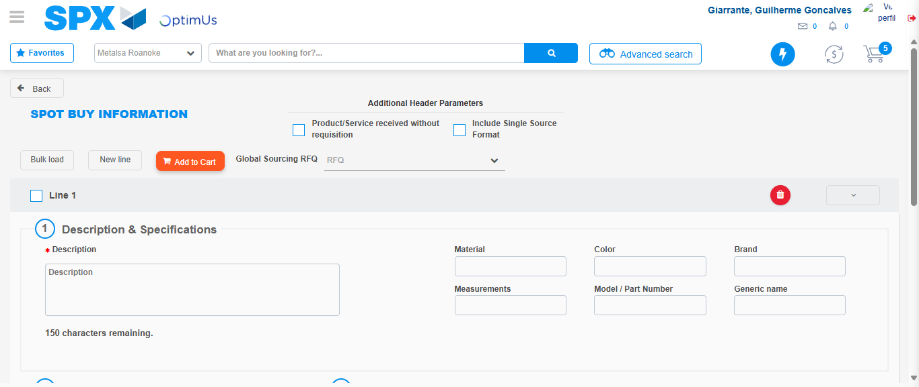Image file-name: QC_Testing-tc002_SPX_Dev5_Crear_Requisicion_Spot_Tipo_Cobro_Project-1784309475531

Step 3 - Data Capture Spot Buy Requisition: Data captured correctly
Image file-name: QC_Testing-tc002_SPX_Dev5_Crear_Requisicion_Spot_Tipo_Cobro_Project-1784309475847

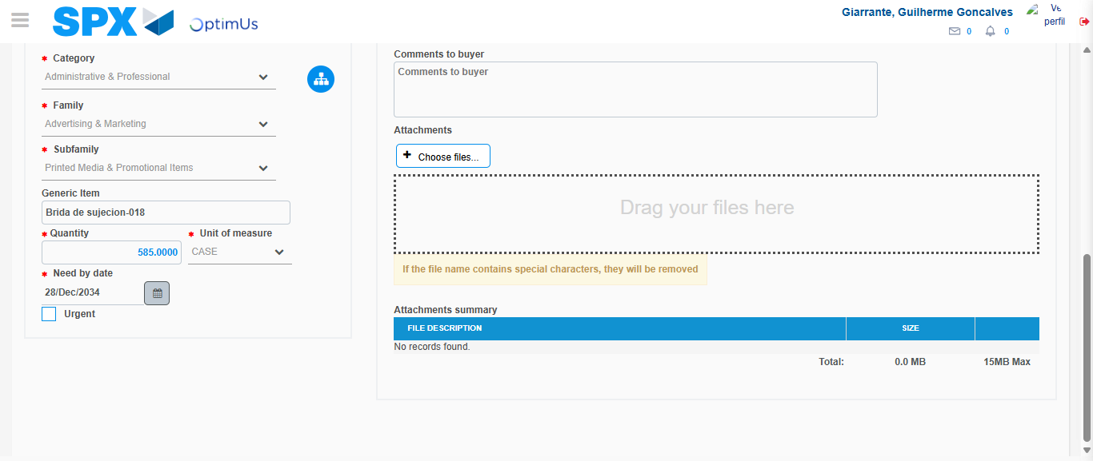Image file-name: QC_Testing-tc002_SPX_Dev5_Crear_Requisicion_Spot_Tipo_Cobro_Project-1784309487645

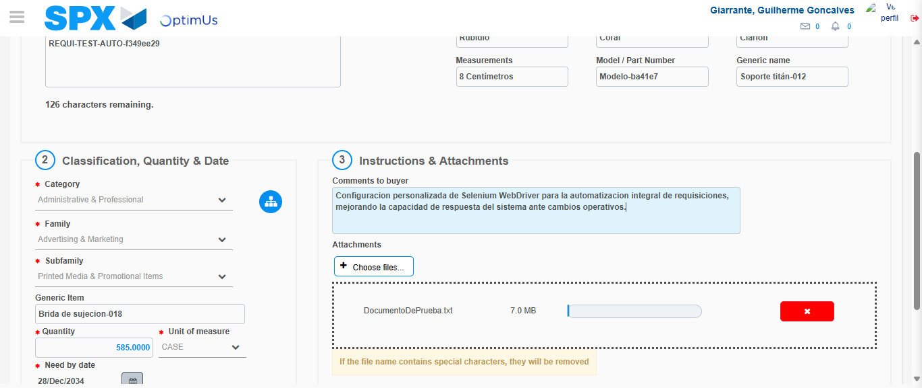Image file-name: QC_Testing-tc002_SPX_Dev5_Crear_Requisicion_Spot_Tipo_Cobro_Project-1784309488643

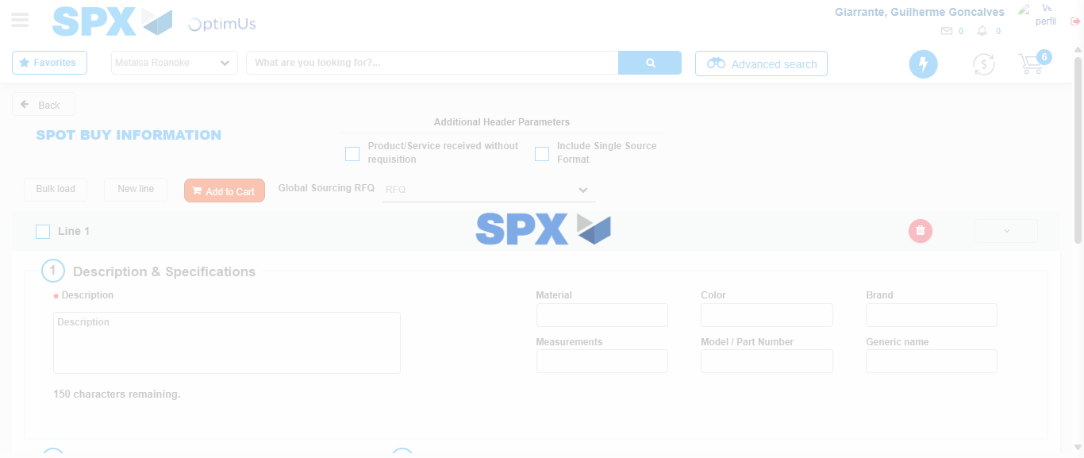Image file-name: QC_Testing-tc002_SPX_Dev5_Crear_Requisicion_Spot_Tipo_Cobro_Project-1784309493215

Step 7 - Return to Main Page SPX : Return to Main Page SPX
Image file-name: QC_Testing-tc002_SPX_Dev5_Crear_Requisicion_Spot_Tipo_Cobro_Project-1784309451656

Image file-name: QC_Testing-tc002_SPX_Dev5_Crear_Requisicion_Spot_Tipo_Cobro_Project-1784309454224

Image file-name: QC_Testing-tc002_SPX_Dev5_Crear_Requisicion_Spot_Tipo_Cobro_Project-1784309475531

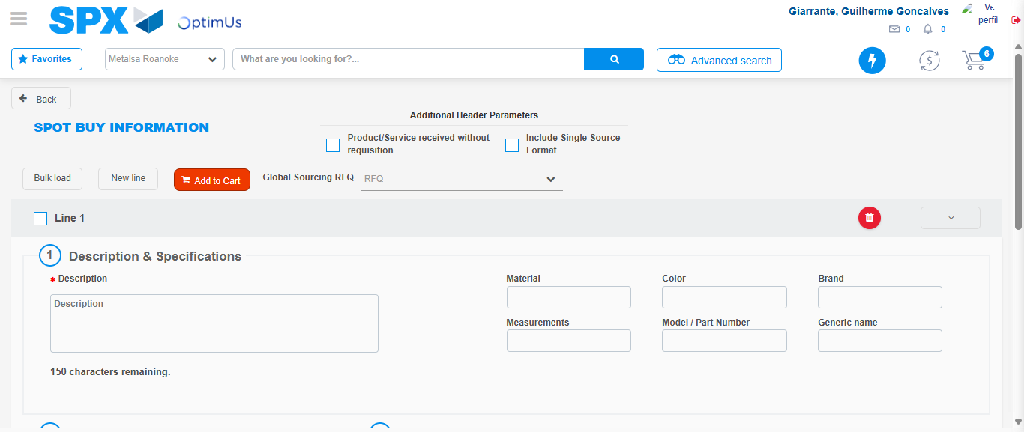Image file-name: QC_Testing-tc002_SPX_Dev5_Crear_Requisicion_Spot_Tipo_Cobro_Project-1784309495488

Image file-name: QC_Testing-tc002_SPX_Dev5_Crear_Requisicion_Spot_Tipo_Cobro_Project-1784309495713

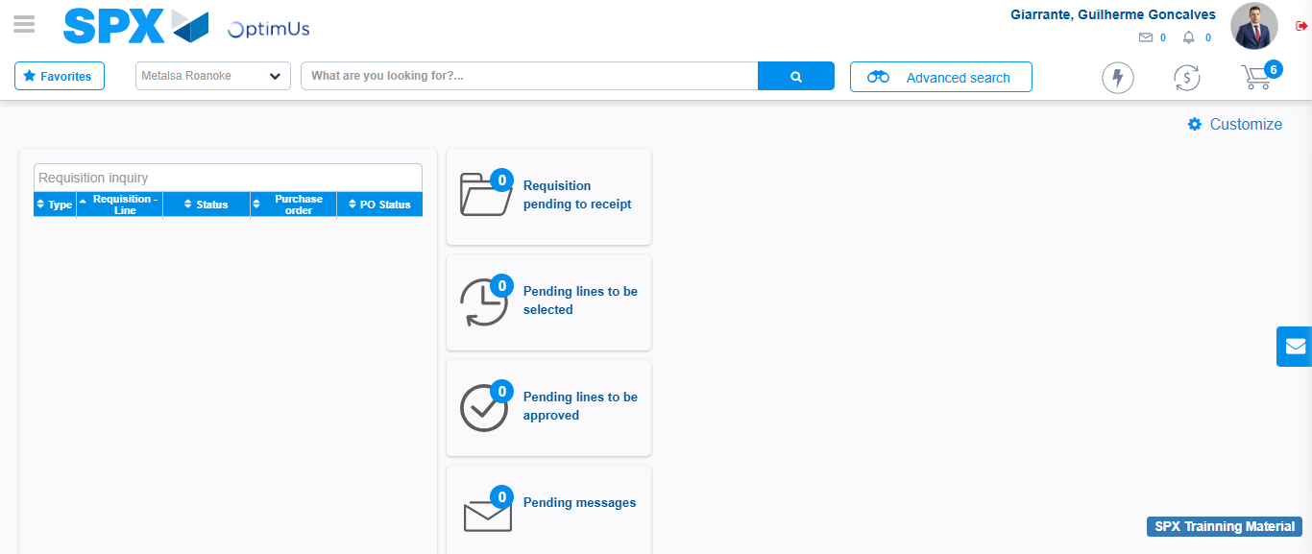Image file-name: QC_Testing-tc002_SPX_Dev5_Crear_Requisicion_Spot_Tipo_Cobro_Project-1784309516917

Step 8 - Log Out : Log Out SPX
Image file-name: QC_Testing-tc002_SPX_Dev5_Crear_Requisicion_Spot_Tipo_Cobro_Project-1784309517157

